**Today’s Agenda**

1. **Improving The Candidate Class**
2. **Defining The CandidateService Class**
3. **Defining The CandidateController Class**
4. **Testing The Candidate API**
5. **Improving The Candidate Class**

**1** Use **@JsonIgnore** on the **List<Vote> votes** field in the **Candidate** entity to ***ignore unnecessary Vote details*** being sent with **Candidate** entity

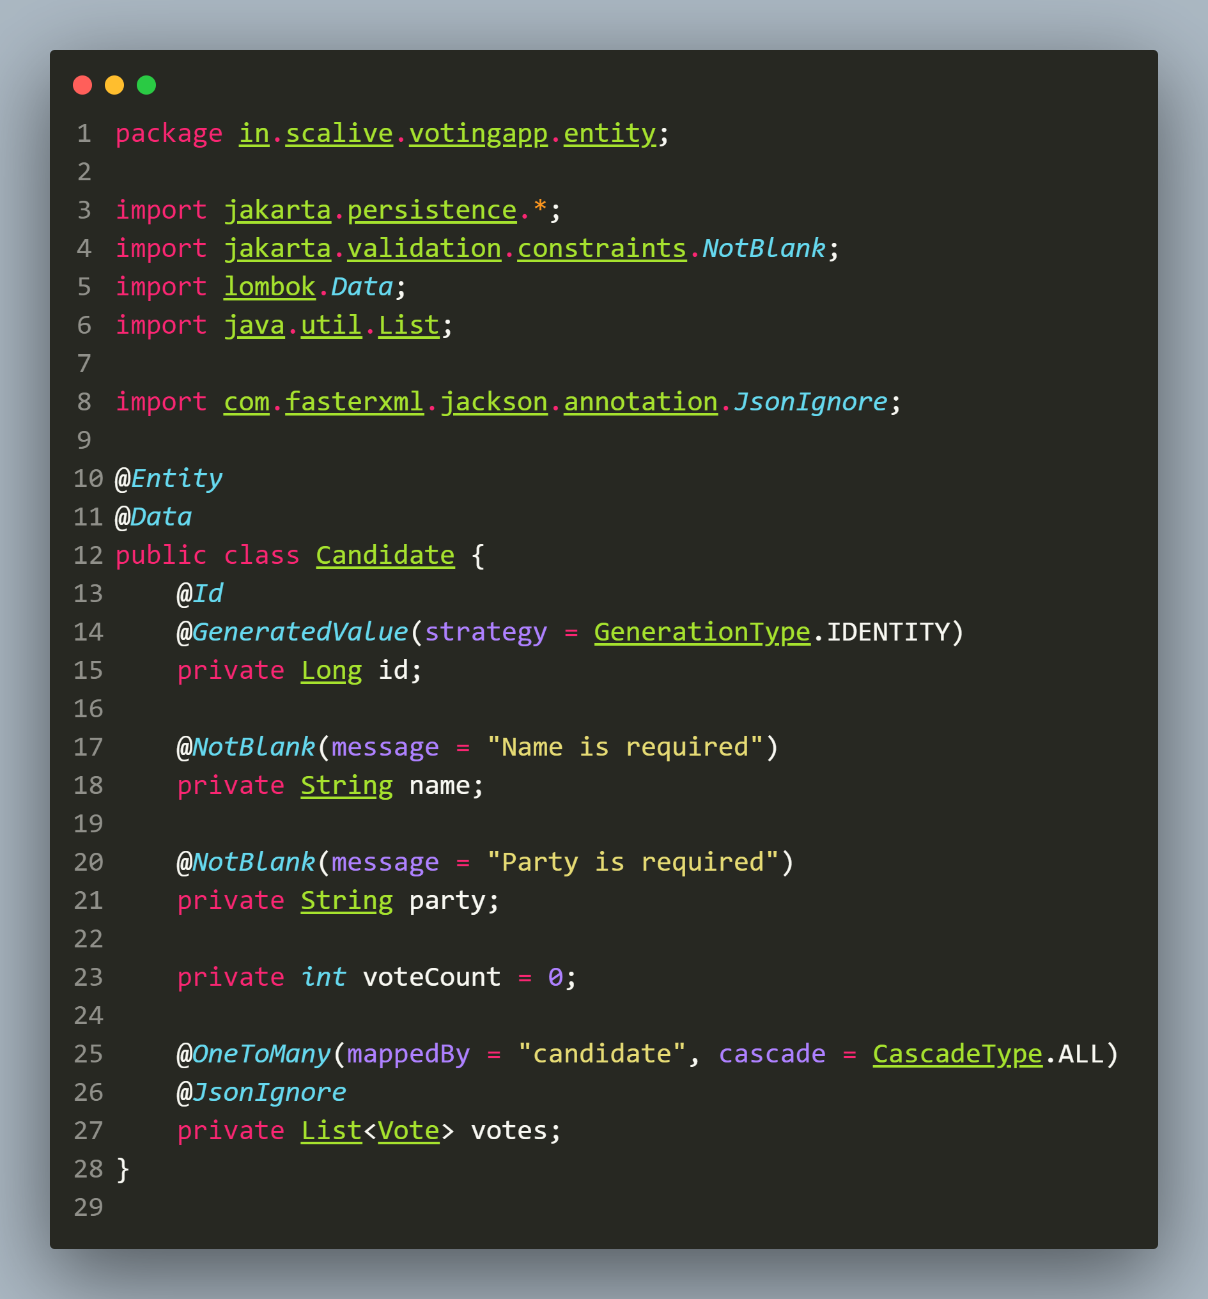

1. **Defining The CandidateService Class**

**📌 Explanation**

**Purpose**: Implements **business logic** for **candidate-related operations** such as:  
 ✔ **Adding candidates** ✔ **Retrieving candidates**  
 **✔ Updating candidates (supports partial updates)** **✔ Deleting candidates**

**📌 Annotations Used**

* **@Service** → **Marks this class** as a **Spring service component**.

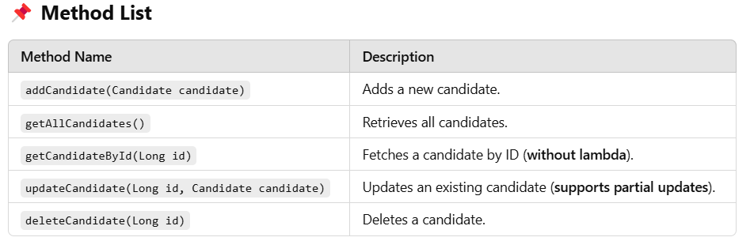

**Code For CandidateService Class**

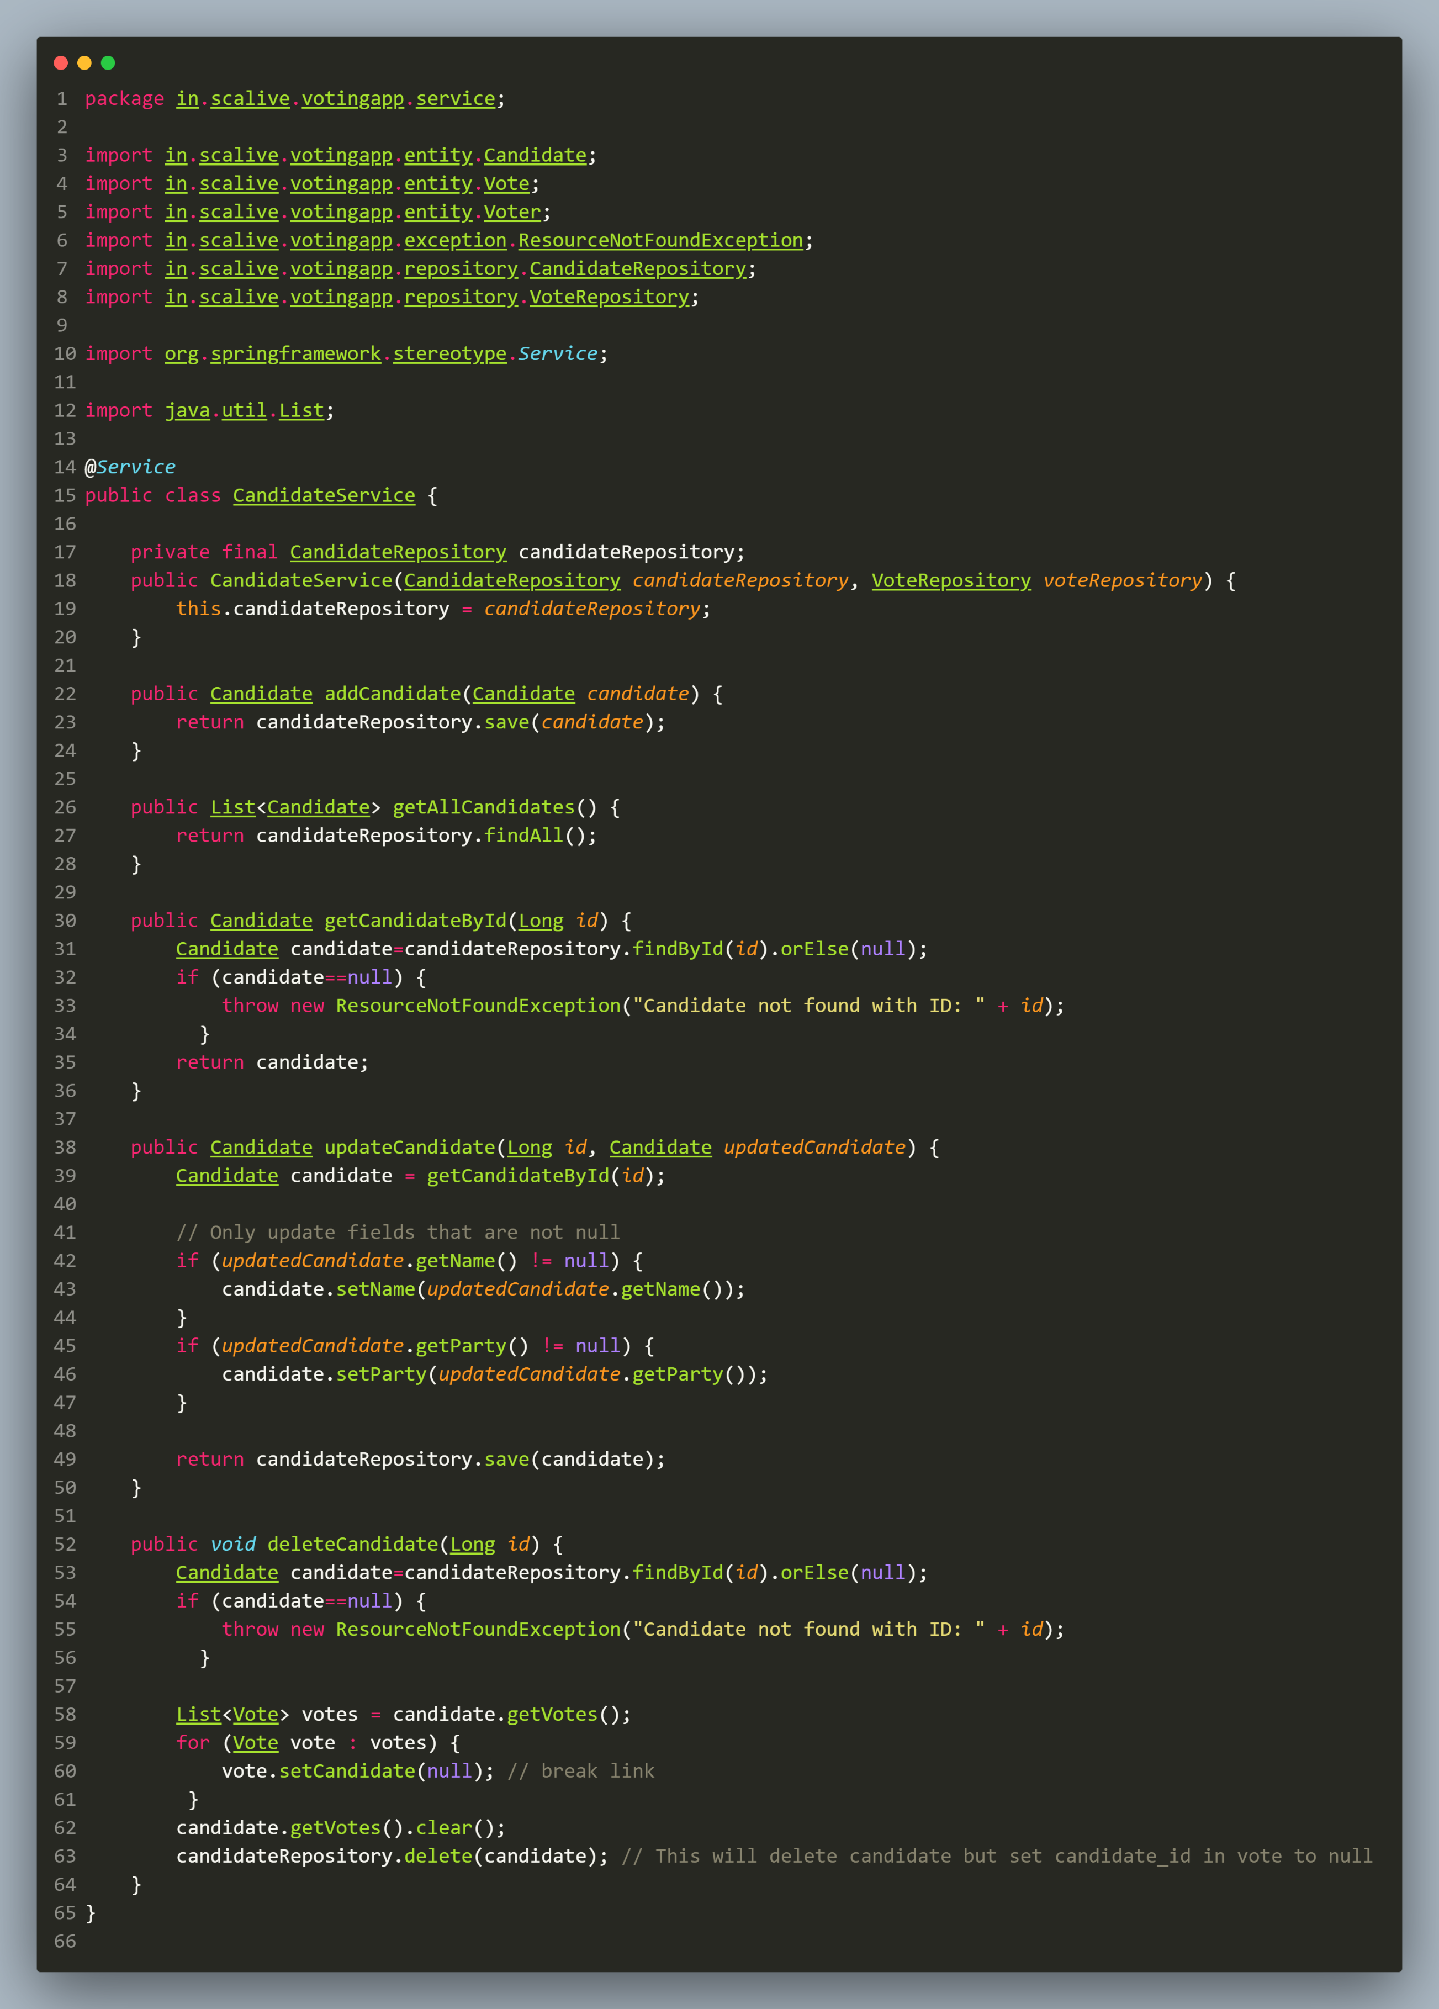

1. **Defining The CandidateController Class**

📌 **Explanation**

**Purpose**: **Exposes REST API endpoints** for managing **candidate-related operations**.

📌 **Annotations Used**

* **@RestController** → **Marks** this class as a **REST API controller**.
* **@RequestMapping("/api/candidates")** → **Base path** for all **candidate-related APIs**.
* **@PostMapping, @GetMapping, @PutMapping, @DeleteMapping** → **Define HTTP endpoints** for **CRUD operations**.

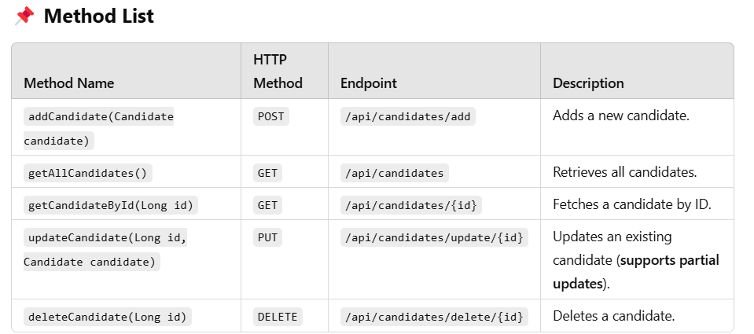

**Code For CandidateController Class**

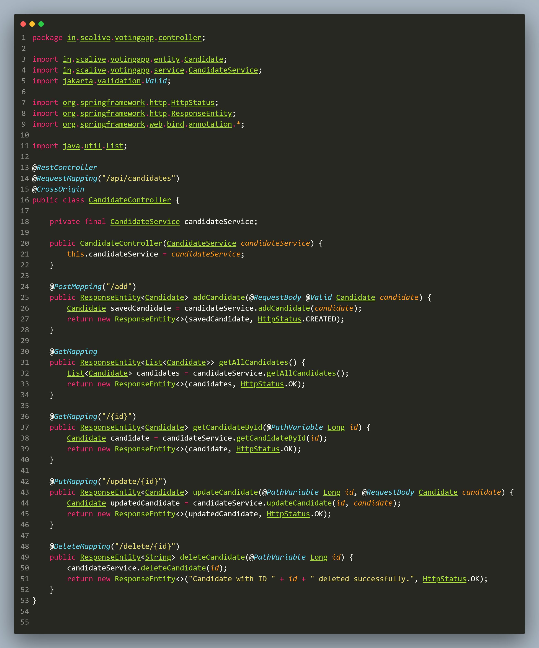

**4.Testing The Candidate API**

1. **Add Candidate: *http://localhost:8080/api/candidates/add***

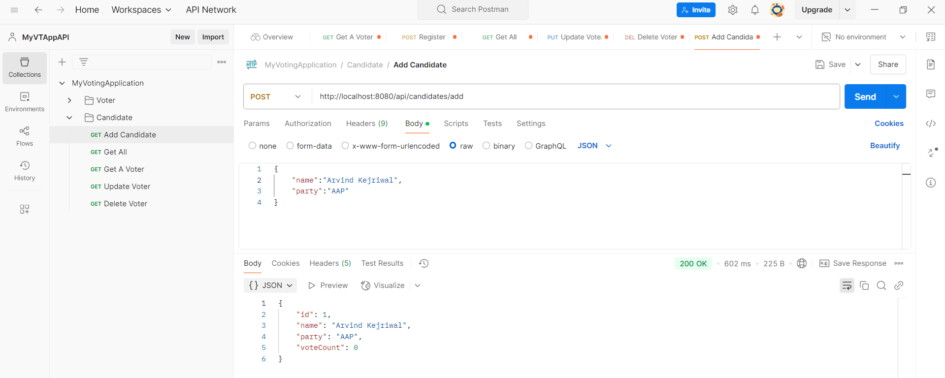

**2.Get Details Of A Candidate:*http://localhost:8080/api/candidates/1***

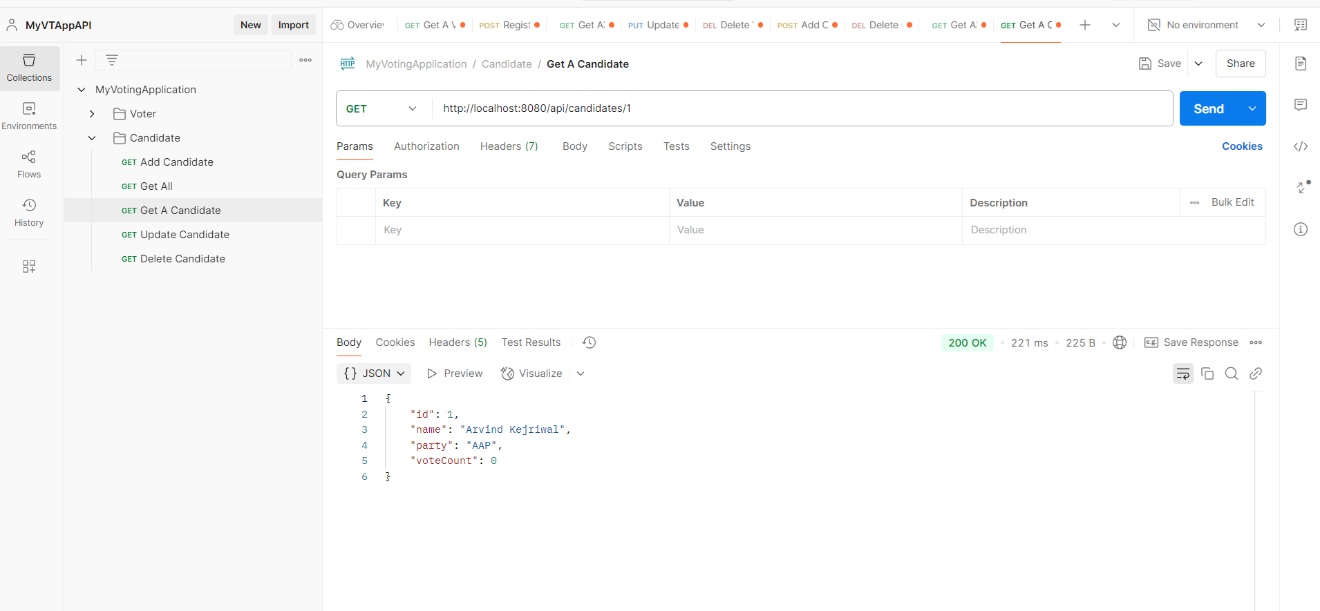

**3.Get Details Of A Non Existing Candidate:*http://localhost:8080/api/candidates/5***

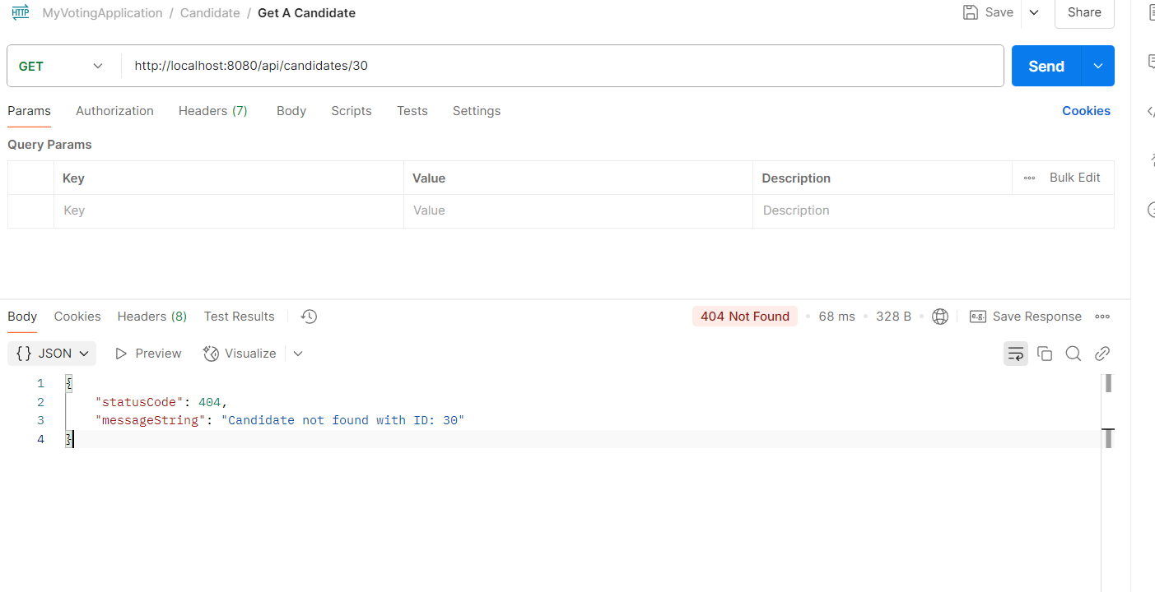

**4.Get Details Of All Candidate:*http://localhost:8080/api/candidates***

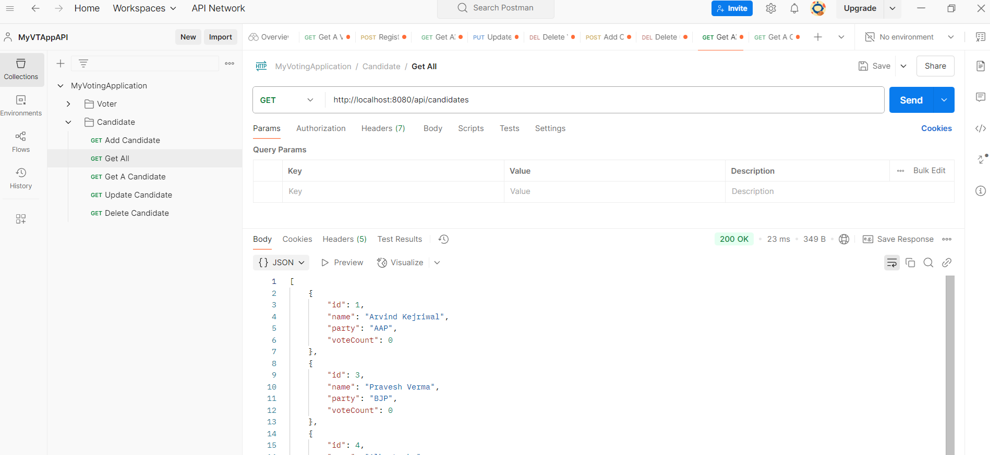

**5.Update A Candidate:*http://localhost:8080/api/candidates***

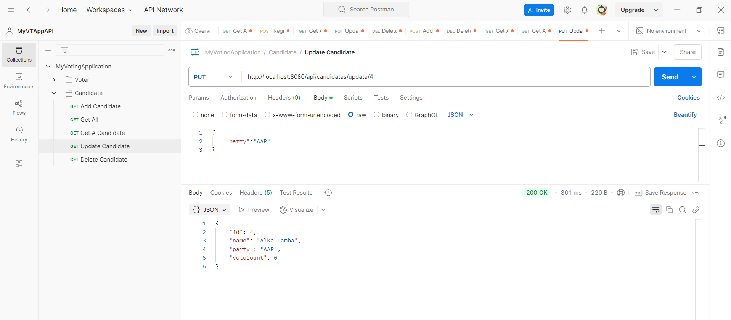

**6.Delete A Candidate:*http://localhost:8080/api/candidates***

